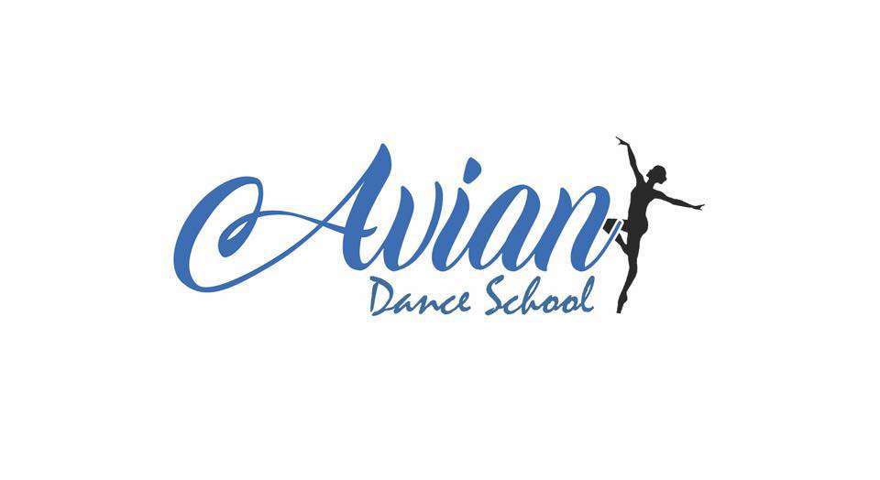
Safeguarding Adults
At Avian Dance School, we are committed to safeguarding adults with care and support needs and will not tolerate any form of abuse or neglect of any adult. We recognise our duty as defined in the Care Act 2014 to safeguard individuals, promote their wellbeing and where ever possible consider their views, wishes, feelings and beliefs whilst doing so. We will take appropriate steps to safeguard any adult who is believed to be at risk or experiencing abuse or neglect and will ensure all safeguarding actions we take allow adults the freedom to make their own choices and will include them in all decision making. All adults have a right to live free from harm and abuse, some may find it hard to get the help and support they need or may be unable to protect themselves from harm and abuse. We recognise our responsibility to support these individuals to receive the safeguarding support they need.
An adult is anyone of 18 years and over.
All staff and volunteers have a strict duty never to subject an individual to any form of harm or abuse. Failure to adhere to these procedures will be treated as gross misconduct.
Individuals who attend Avian Dance School may view our policy where appropriate and a copy will always be kept on our website and in paper form at Avian Dance Studios.
Designated safeguarding lead:
The designated safeguarding person (DSP) within our organisation is Principal, Harriet Wigger.
The Designated Safeguarding Person will advise members of staff and visitors at Avian Dance School on best practice and expectations. They will be responsible for the monitoring and recording of any safeguarding concerns and for ensuring that all concerns are shared with the appropriate statutory authorities.
All staff and volunteers at Avian Dance School should be made aware of this policy and should be able to demonstrate their roles and responsibilities for safeguarding and promoting the wellbeing of individuals, including how to raise concerns with both Adult Social Care and the Police. Staff and volunteers shall be made aware of this policy through regular conversations, staff meetings and training.
Safeguarding adults:
‘Safeguarding adult’s means protecting an adult’s right to live in safety, free from abuse and neglect. It is about people and organisations working together to prevent and stop both the risks and the experience of abuse or neglect, while at the same time making sure that the adults wellbeing is promoted including, where appropriate having regard for their views, wishes, feelings and beliefs in deciding on any action. This must recognise that adults sometimes have complex interpersonal relationships and may be ambivalent, unclear or unrealistic about their personal circumstances.’ (Care and Support Statutory Guidance 2017.)
All safeguarding work should be underpinned by an ethos of empowerment, prevention, proportionality, protection, partnership and accountability.
The Care Act sets out a duty for any adult who:
- Has care and support needs ( whether or not these are known to the local authority where they reside)
- Experiencing or is at risk of experiencing abuse or neglect and
- Is unable to protect themselves due to their care and support needs.
Any safeguarding action should be person lead and outcome focuses. We should help the individual to receive the kind of help and support that is right for them.

Overview of responsibilities:
All staff and volunteers must report all concerns to the designated safeguarding lead at the nearest available opportunity.
It is the responsibility of all staff and volunteers at Avian Dance School to take steps to protect adults with care and support needs where they are unable to do so for themselves.
It is the responsibility of all staff and volunteers to take reasonable steps to protect people from harm and abuse while in contact with Avian Dance School and our staff and to report any incident of or suspicion of abuse to the Designated Safeguarding Person or in their absence to the appropriate statutory authority.
All staff working at Avian Dance School who have contact with people with care and support needs are required to hold a valid, clear DBS check.
Consent and information sharing:
Issues of consent are essential to effective safeguarding practice. Additional consent must be sought for any activity that is out of the usual parameters of our work. Basic consents for day to day activities can be sought through enrolment process; including photo consent and consent for performances, and appropriate organisational guidance shall be provided to ensure those consenting have clear and transparent information on what they are consenting to.
Significant harm is no exception to this. Before making a referral to Adult Social care consent must be sought. Adult safeguarding Process is consent based process and support cannot be provided for an individual who doesn’t want it. Conversations about consent must be recorded.
Consent need not be sought, and action should be taken, where:
- There is immediate risk to that individual or others, often known as a public protection issue.
- Asking for consent is at that time unsafe
- The individual lacks the mental capacity to consent therefore you do so on their behalf.
Any information shared will be relevant, necessary and proportionate. You must record your decision and the reasons for it, whether or not you choose to share information. If you share you should record what you shared and who you shared with.
Staff and volunteers must be aware there are many barriers for individuals who may wish to share experience of abuse or neglect to seek help and support. Patience and reassurance are essential.

The Mental Capacity Act 2005: is a legal framework which protects people who may lack capacity to make decisions themselves. The presumption is that adults have mental capacity to make informed choices about their safety and how they live their lives. Mental Capacity and a person’s ability to give informed consent are at the heart of decisions and actions taken under this policy.

A person’s ability to make a decision may be affected by duress and undue influence. Adults with capacity would normally make their own in- formed decision as to whether they consented to be involved in the adult safeguarding process. If it is reasonably believed that the decision is being made because of threats or coercion expert advice should be sought.

Seeking medical attention:
If anyone has a physical injury, and there are concerns of abuse, medical attention should be sought immediately. Any safeguarding concerns should be shared with ambulance or hospital staff and then must be reported to Adult social care.

Nothing should be allowed to delay urgent medical treatment.

Abuse and Neglect: Our duty to safeguard adult’s means:
- Stop abuse and neglect where possible
- Prevent harm and reduce the risk of abuse or neglect to adults with care and support needs
- Safeguarding adults in a way that supports them in making choices and having control about how they want to live
- Promote an approach that concentrates on improving life for the adults concerned
- Raise public awareness so that communities as a whole, alongside professionals, play their part in preventing, identifying and responding to abuse and neglect
- Provide information and support in accessible ways to help people understand the different types of abuse, how to stay safe and what to do to raise a concern about the safety or well- being of an adult and
- Address what has caused the abuse or neglect
(14.11: Department for Health Care and Support Statutory guidance, issued under the Care Act 2014)

Staff and volunteer responsibility:
All staff and volunteers at Avian Dance School have a duty to:
Take action: This might involve;
- contacting the police or phoning an ambulance or taking some other form of emergency safety measure,
- Offering support, information and reassurance to the individual
- Collect details about what has happened where possible being mindful not to be disruptive of potential evidence (don’t ask leading questions)
- Gain consent to share information where possible or act in the individuals best interests where they are unable to consent.
Tell:
- Our designated safeguarding lead or in their absence adult social care or the police

Record:
- As much detail as possible as soon as possible with accurate information.

Raise your concern:
- With Adult social care where an individual requests this support or in their best interests under the MCA if they are unable. Share with the police where appropriate.

Confidentiality:
At Avian Dance School, we expect all members of staff and volunteers to maintain confidentiality at all times and to act in line with the General Data Protection Regulations and to there for share only that which is necessary, proportionate and relevant.

Referring a concern and your DSP:
Our Designated safeguarding person will act on behalf of Avian Dance School in referring concerns or allegations of harm to Adult Social care or the police as appropriate. If the designated safeguarding lead is in any doubt information should be shared with Adult Social care for a second opinion. It is not the role of the DSP to investigate only to collate information, clarify details of the concern and facilitate information sharing. In the absence of the DSP the individual who has the concern is responsible for contacting Adult Social care and the information should be shared with the DSP retrospectively.
The contact number for Adult social care is: Norfolk County Council: 0344 800 8020

Allegations against staff members/ volunteers:
If any member of staff has concerns about another member of staff or volunteer at Avian Dance School such as;
- Believing they have behaved in a way that has harmed or may cause harm to an individual
- Having possibly committed a criminal offence against or relating to an adult with care and support needs
- Behaved toward an adult with care and support needs in a way that indicates he/ she is unsuitable to work with people. (This could be within the work place within the community or their own families).
The allegation or concern should be reported to the manager with responsibility for dealing with allegations immediately. This is Harriet Wigger, Aimee Cooper or Lauren Stearman (Principals)
Neither the member of staff who has raised the concern/ allegation nor the member of staff who is alleged against should be allowed to question individuals or be part of any further investigation.
The designated manager for Avian Dance School will report the matter to the Local Authority safeguarding Adults Team.
If an allegation or concern arises about a member of staff, outside of their work at our organisation, and this may present a risk of harm to others for whom that member of staff is responsible, the general principles outlined in this policy will still apply.
Staff recruitment:
When recruiting paid staff and volunteers it is important to always follow the process outlined in the safer recruitment policy – found in our child safeguarding policy. This will ensure potential staff and volunteers are screened for their suitability to work with adults with care and support needs.
This policy will be reviewed annually.
Date of last review: January 2021
Signed: Harriet Wigger (Designated Safeguarding Person)

Appendix A:
care and support needs could include:
- An older person
- Someone with sensory impairment
- Someone with a mental health condition, personality disorder or dementia
- Someone with a physical disability
- Someone who misuses substances or alcohol to the extent if effects their ability to manage day to day living
- A carer, providing unpaid care for a family member or friend.
- (This is not a comprehensive list, it is purely examples.)

Appendix B:
Illustrative guide to abuse and neglect:
- physical abuse - this includes assault, hitting, slapping, pushing, misuse of medicines, restraint, or inappropriate physical sanctions
- sexual abuse - this includes rape, indecent exposure, sexual harassment, inappropriate looking and touching, sexual teasing or innuendo, sexual photography, subjection to pornography or witnessing sexual acts, sexual assault, sexual acts to which the adult has not agreed or was pressured into agreeing to
- psychological abuse - this includes verbal abuse, emotional abuse, humiliation, cyberbullying, the use of threats of harm or abandonment, deprivation of contact, blaming, controlling, intimidation, coercion, harassment, isolation or unreasonable and unjustified withdrawal of services or support networks
- financial abuse - this includes theft, fraud, internet scamming, coercion in relation to the adults’ financial affairs or arrangements and the misuse of property, benefits or possessions
- modern slavery – encompasses slavery, human trafficking, forced labour and domestic servitude by Traffickers and slave masters using whatever means they have at their disposal to coerce, deceive and force individuals into a life of abuse, servitude and inhumane treatment
- discriminatory abuse - including forms of harassment, slurs or similar treatment because of race, gender and gender identity, age, disability, sexual orientation or religion
- organisational abuse – including neglect and poor care practice within an institution or specific care setting such as a hospital or care home or in relation to care provided in the adults own home. This may range from one off incidents to on-going ill-treatment and can be through neglect or poor professional practice as a result of the structure, policies, processes and practices within an organisation
- neglect and acts of omission - including ignoring medical, emotional or physical care needs, failure to provide access to appropriate health, care and support of educational services or the withholding of the necessities of life such as food, medication and heating
- self-neglect - this covers a wide range of behaviour such as neglecting to care for one’s personal hygiene, health or surroundings and includes behaviour such as hoarding
Appendix c:

Sample suggested signs, symptoms and indicators to abuse and neglect:
- Depression
- Self-harm
- Suicide attempts
- Fear or anxiety
- Being dirty, smelly, unkempt
- Lacking proper clothing for the time of year
- Lacking money to meet their basic needs
- Injury
- Sleeplessness
- Changes in mood, behaviour or appearance

