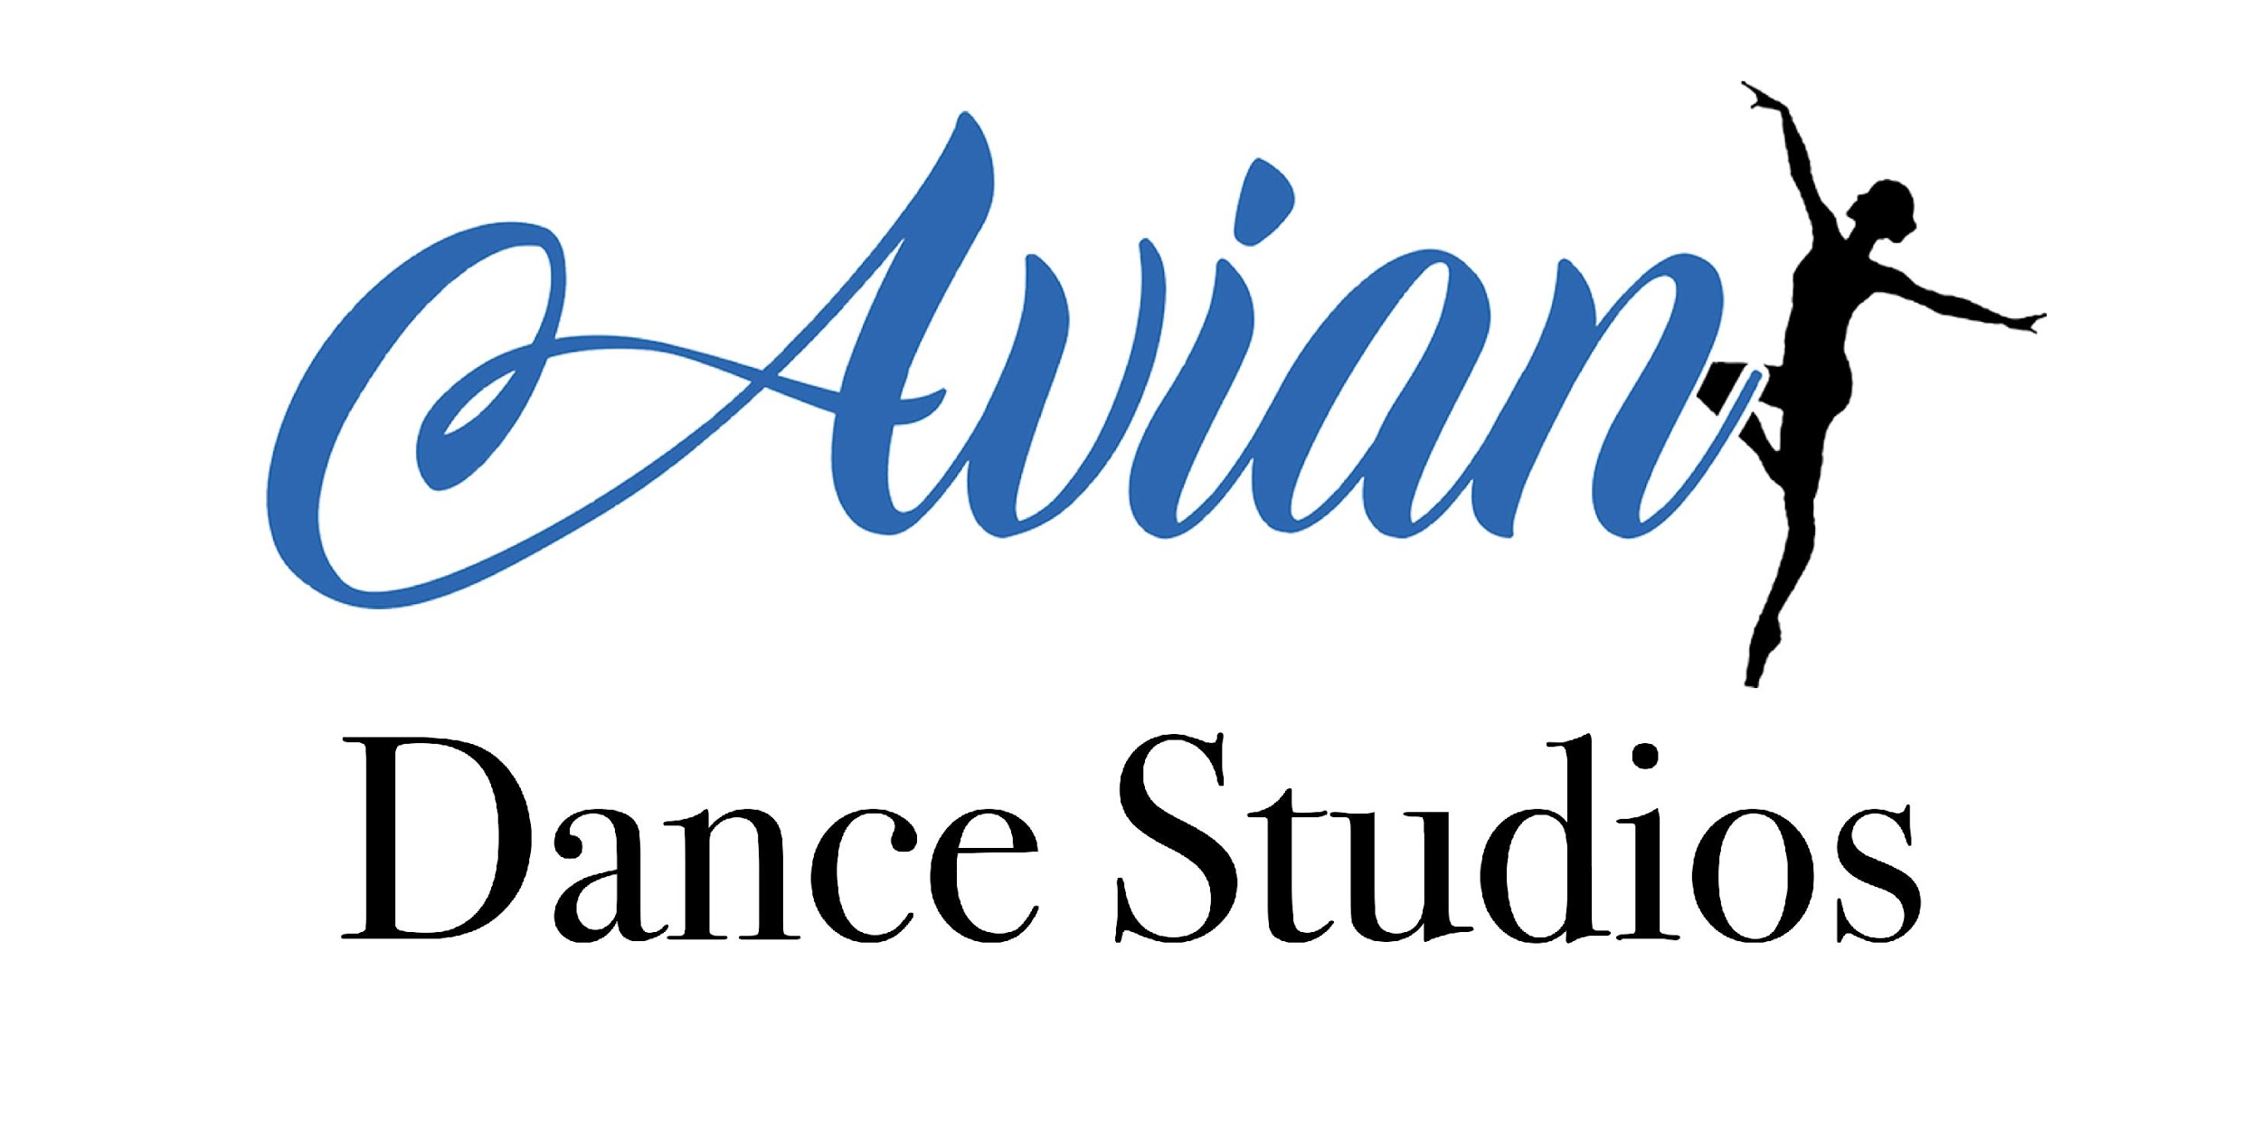
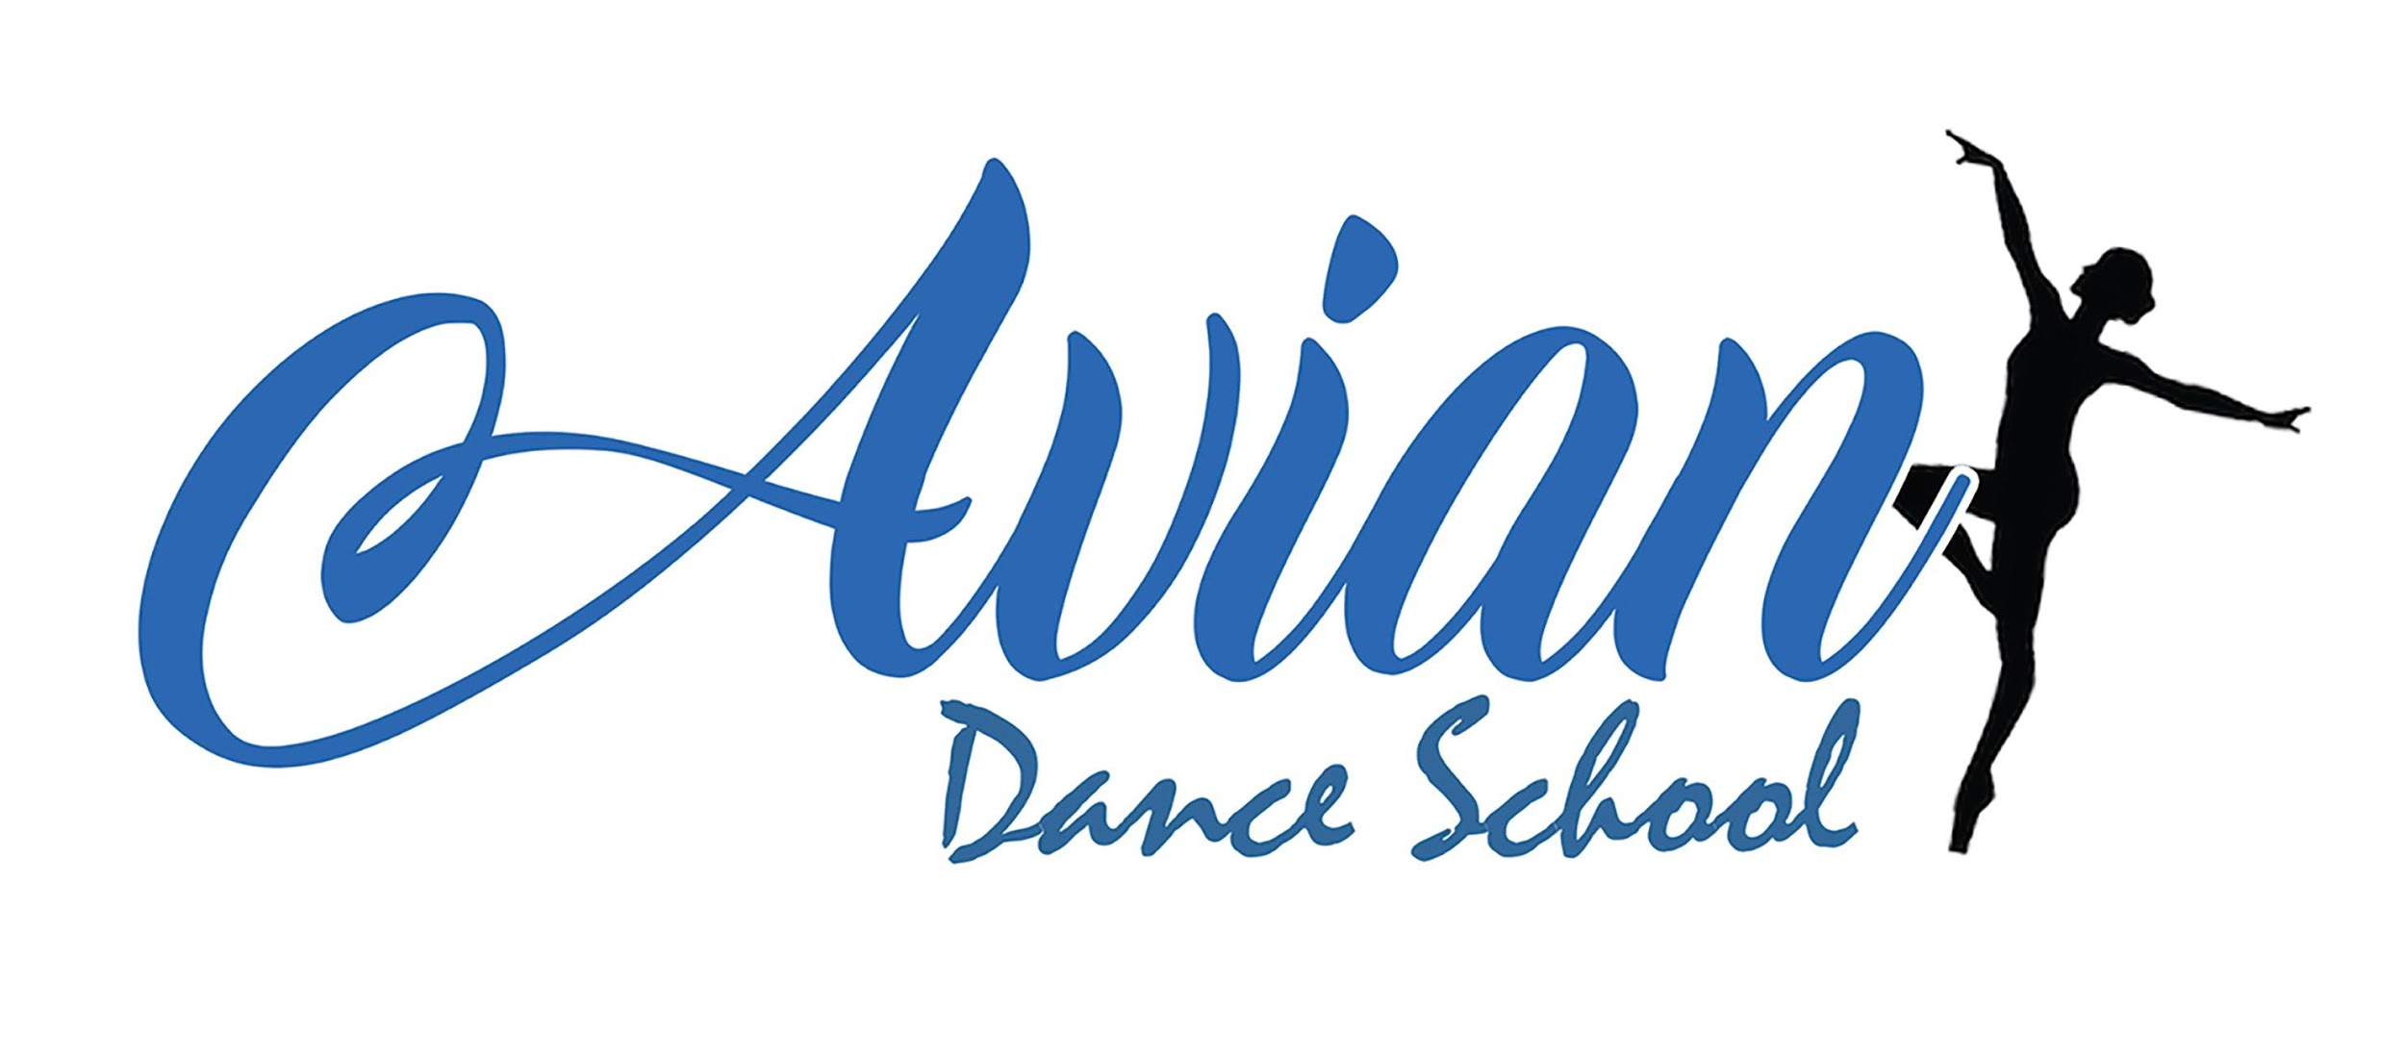

Avian Coronavirus (COVID-19) Policy

Policy Brief and Purpose
This policy has been created to include measures we are actively taking to reduce the spread of coronavirus. We kindly ask that all measures are followed diligently to sustain a healthy and safe dance school environment for our students and hirers during these unprecedented times.
Avian Dance School/Avian Dance Studios Coronavirus (COVID-19) Policy is susceptible to change according to the on going updates and guidance from the government. All guidance can be found via the government website: www.gov.uk
This policy applies to all Avian Dance School teachers, students and families as well as Avian Dance Studios hirers.

Policy Elements:
Here, we outline the required actions that we all should take to protect ourselves and others from a potential Coronavirus infection.
- i) If you or a member of your household display coronavirus symptoms according to the current government published list, please do not attend Avian Dance Studios. Please contact the Principals via info@aviandanceschool.com so we may follow current governmental guideline to notify staff and families if necessary in line with the current guidance.
- ii) Staff should contact Harriet Wigger, Aimee Cooper or Lauren Stearman via telephone.
- iii) If you have a positive COVID-19 diagnosis, you can return to Avian Dance School’s classes or Avian Dance Studios’ hirer classes only after you’ve fully recovered having followed the current governmental guidelines detailing self-isolation timescales which may be subject to change.
General Hygiene Rules
- i) Students are not to enter the studio until invited in by the teacher.
- ii) Students are encouraged to enter reception applying antibacterial hand gel and leaving their personal belongings in the changing rooms. We will ask students to be respectful of the space and encourage as few of them in the changing rooms as possible at any one time.
- iii) Upon leaving the studio, students will be encouraged to apply antibacterial hand gel again and collect their belongings.
- iv) Students should be respectful of those choosing to keep their distance and of those choosing to wear a facemask – however these are no longer obligatory.
- v) Adults and children over the age of 11 (unless exempt) are expected to wear a face mask in all communal areas or alternatively keep their distance by dropping and collecting at the door as we cannot guarantee social distancing will be achievable in the building. Masks do not have to be worn in the studio whilst taking part in dance/fitness classes.
- vi) Posters will be displayed as well as verbal reminders to wash hands thoroughly after using the toilet. Antibacterial wipes will be provided should they choose to use them before use. The facilities will be cleaned at the end of every evening as a minimum.
- vii) The toilets, door handles and studio surfaces will be regularly wiped after every evening by Avian Dance Studios staff and hirers.
- viii) Air conditioning units will be running in the studio to provide ventilation and we will encourage doors being opened between classes for fresh air to enter.
- ix) Spotting and physical support in classes will resume in line with our safeguarding policy and waiver below. All students reserve the right to refuse if they do not feel comfortable. They also have the option to wear a mask.
- x) In the case of a student having to self isolate due to either contracting COVID-19, or self isolating because a family member has contracted the illness, we will aim to offer zoom links – there will be no refunds or discounts from Avian Dance School for such circumstances.
- xi) Adults using reception area are encouraged to use hand sanitiser on entry and exit as well as remaining seated as much as possible. They encouraged to use track and trace by filling in their name and contact number and the date they were there or scanning the QR code, however, this is no longer obligatory.
National Risk Level
Should the national risk level make it unsafe for Avian Dance School or hirers to continue classes in Avian Dance Studios, classes will be reverted to an online provision following the same timetable, where possible, as the previous term for continuity (this may not be the case for our hirers). Where a term is commencing online, this is the only scenario in which classes will be discounted. This price will be communicated with parents prior to the term. 1 half terms’ notice continues to be applicable. The wellbeing of our students will always be our priority.

Disclaimer: Avian Dance School and Avian Dance Studios endeavors to create a safe environment for all of our staff, students and hirers, however we are unable to guarantee a completely risk free environment. Due to the current unprecedented times, Avian Dance School and Avian Dance Studios reserves the right, where necessary, to make changes to any aspect of the provision of its services without notice.
Waiver: I am aware that participating in dance, acrobatic arts and performing arts classes involves inherent risks and hazards. I freely accept and fully assume the possibility of personal injury, property loss or damage and illness in the studio or via online classes.
PAYMENT OF YOUR INVOICE IS ACKNOWLEDGMENT THAT YOU HAVE READ AND UNDERSTOOD THIS POLICY. IT WILL BE AVAILABLE ON THE WEBSITE AT ALL TIMES AND ALSO REFFERED TO IN YOUR ENROLMENT CONFIRMATION EMAIL.

