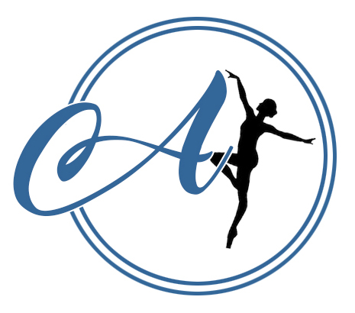
AVIAN DANCE SCHOOL RULES AND REGULATIONS

- Classes are invoiced for every half term with payment for the full half term expected. This can be paid via bank transfer or cash.
- Payment is expected within 2 weeks after receiving the invoice. You will receive the invoice 2 weeks prior to classes beginning. If payment is not made by this time, without contact, students will not be permitted to take part in the classes. Registers will be updated accordingly and only names on the registers will be allowed into class.
- We reserve the right to change our packages and will ensure to give the school a half terms notice.
- When paying by bank transfer, please use the invoice number as the reference. If paying by cash - please bring in a sealed envelope, labelled with your invoice number, student’s name and amount enclosed.
- New students have a 28 day ‘trial period’ where they have the right to cancel without notice and receive a refund for unattended classes.
- As fees are paid a half term in advance, we ask for a half term’s notice if you no longer wish to attend classes and fees are payable during this period.
In regards to COVID-19 lockdowns and closures:
- Credit will be applied to invoices for cancelled classes
- Zoom classes will be offered in place of studio classes should we be advised to close
- We will offer a £1 discount per class if we use zoom due to a full lockdown and studio closure
- No discount will be given for zooms undertaken because of government class restrictions or self isolation
- If payment for the term has already been made, cancelled credit and discounts will be applied to your following invoice.
- We do not expect students to buy the school uniform in their first half term of classes, however they are welcome to do so. Uniform expectations for each class can be found in your confirmation email, or you can ask the Principals.
- Jewellery is not permitted during classes; this is a health and safety hazard. We will allow small studs to be worn in ears.
- Avian Dance School is not responsible for personal possessions that are damaged or lost during our classes.
- To avoid the hindrance of other student’s learning, disruptive and inappropriate behaviour will not be tolerated.
- Avian Dance School is committed to keeping customers up to date and does so via email, Social Media (mostly Facebook) and Whatsapp. We politely ask you provide us with up to date contact details. It is your responsibility to keep an eye on these forms of contact to avoid missing important information.
- In their first class, all students over the age of 13 and parents/guardians/carers are required to sign a permission sheet to advise us as to whether they allow photography and videography of the student.
- We ask that you please read through our policies and procedures, these can all be found on our website and are also printed and available to read at the studio.
- We ask you fill in a registration and disclosures form and read and sign our COVID-19 policy and waiver and return by email to info@aviandanceschool.com before you attend a class or free trial. All data is held in accordance to our GDPR policy available on our website.

By paying your invoice to secure your child's place, you are agreeing to these terms and conditions.

